The science of landscapes: Earth and planetary surface processes
Winter 2020
Problem set 3

Due in my mailbox (1st floor Hinds) or via email, 5p Thursday 13 Feb.

Question 1. (a) Compute the rate of basal melting of a warm-based slab of H₂O ice on Mars that is much wider than it is tall, assuming a lithospheric heat flow of 30 mW/m² and a range of ice thicknesses from 0.3 km to 3 km. Consider conductive losses but not advective heat transport. (b) Now assume the H₂O ice slab is in 1D steady state mass balance (snow supply at top of ice column = melt loss at bottom of column, with melt water swiftly evacuated to great distances). The Peclet number (Pe) is the ratio of advective heat transport to diffusive (in this context, conductive) heat transport. Peclet number = u L / α where L is thickness, u is velocity, and α is thermal diffusivity. What is the Peclet number for your steady-state ice slabs?

Question 2. (Part of Melosh Problem 11.3, from https://geosci.uchicago.edu/~kite/doc/Melosh_ch_11.pdf). Derive the velocity profile for an infinitely wide, isothermal 250K sheet of Glen’s law material (ice), of uniform thickness H, creeping down a surface with a constant slope s. The bottom boundary condition is zero-slip. Set
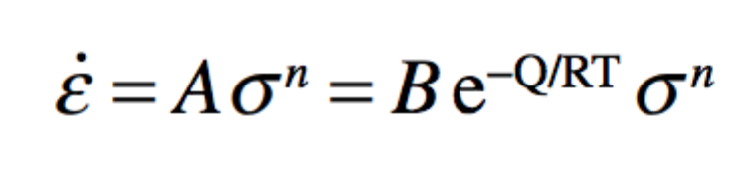
with n = 3.2, Q = 180 kJ/mol, and B = 3.5 × 10²⁰ MPa^{–3.2}s ^{–1}.

Question 3. A very extensive, 3 km thick ice sheet flow into a very extensive bay floored by rock that is initially 1 km below sea level (i.e. initial water depth 1 km). What is the elevation of the ice sheet above sea level after enough time has elapsed to reach isostatic balance? Assume that both ice sheet and bay are much larger than the flexural wavelength.

