GEOS 32060 / GEOS 22060 / ASTR 45900

What makes a planet habitable?

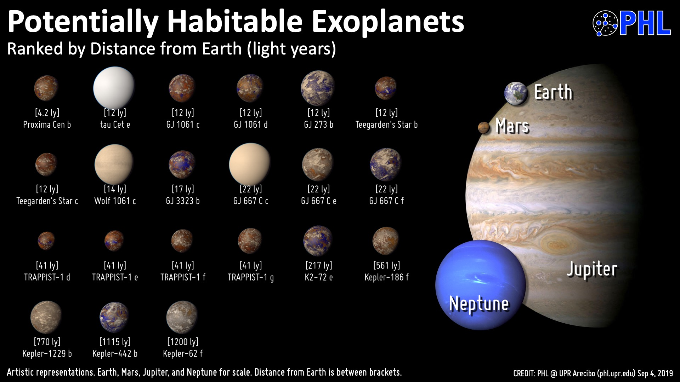

Only the radii and distances of the exoplanets are known. All other detail is filled in by the artist.

Instructor: Edwin Kite, kite@uchicago.edu
(Geophysical Sciences; research is on Mars, rocky exoplanets, icy moons).

Website: geosci.uchicago.edu/~kite/geos32060_2020 (required reading, homework). (Website will be active before end 1/9).

Homework: Issued once per week, due 1 week after being issued. Late policy: 10% reduction in maximum grade per day late. Exceptions in case of medical emergency, family emergency, e.t.c.

Grades:
People enrolled in undergraduate course: 50% homework, 35% final, 15% in-class presentation. Undergraduates may choose to do a term paper if they wish. Undergraduates who choose to do a term paper will be graded using the graduate course percentage breakdown, however scoring for undergraduate term papers will use a different scheme from grading of graduate-course term papers.
People enrolled in graduate course: 30% homework, 30% final, 15% in-class presentation, 25% term paper (term paper is required for graduate students).
There will not be a midterm. Final will be closed-book, but you will be provided with basic quantities (mass of Earth, molar mass of CO₂, e.t.c.), and in addition you can bring one sheet of paper with your own hand-written notes on one side of the paper.

Class participation will be considered in determining final grades for people who are at a grade borderline.

Reading: Required reading every week (1-2 papers or 3-4 selections)
(+ optional, supplemental reading).

Textbook: None. PDFs of chapters from Catling & Kasting Atmospheric Evolution on Inhabited and Lifeless Worlds, Knoll et al. Fundamentals of Geobiology, Langmuir & Broecker How to build a habitable planet, e.t.c. will be made available.

Paper presentations: You will be assigned a paper to present by the instructor. You are encouraged to make a powerpoint presentation (chalkboard presentations are allowed). Students will make 20 minute presentations, followed by class discussion.

Term paper: Undergraduate students who choose to do a term paper: Four-page literature review, Nature style, of a topic of your choice (undergraduate students). You may exceed four pages. Graduate students: Four-page literature review, Nature style of a topic that is not directly connected to your thesis area (check the topic with the instructor), or four-page original research which may be related to your thesis research. You may exceed four pages. All students: Consider http://www.planetary.brown.edu/pdfs/4794.pdf as a “longer” model for Nature style.

Office hours: Thursdays, 11a-noon (after class). Hinds 467, or by appointment kite@uchicago.edu. Please email at least 48 hours in advance with a range of suggested times. [Please note that this office hours time is flexible, if two or more students would like regular office hours at some additional time, please email me and I can probably add that.]

Collaboration policy: You are allowed to discuss course material and homework assignments with each other, but you must work out and write up each problem solution by yourself without assistance. Exchanging solutions to homework problems or sharing solutions is strictly prohibited. It is a violation of this policy to submit a homework solution that you cannot explain orally to the instructor/TA. Copied solutions obtained from a written source, from the internet, or from another person will receive zero credit.

