GEOS 32060, Class 9
29 February 2016

Zeebe’s LOSCAR and Tziperman’s biogeochemical ocean model

Background. The two models you will use today – Richard Zeebe’s Long-term Ocean-atmosphere-Sediment CArbon cycle Reservoir Model (LOSCAR) and Eli Tziperman’s ocean biogeochemical model - represent state-of-the-art Earth habitability models. The model description paper for LOSCAR is http://www.soest.hawaii.edu/oceanography/faculty/zeebe_files/Publications/ZeebeGMD12.pdf . Both models are used to predict Earth’s response to ongoing and past environmental perturbations. Both are box models; neither explicitly represents latitude, longitude, or depth within the sediment (although Loscar does track different depths within the ocean, as separate boxes). Both were written by a single person, and both take up <10⁴ lines of (well-commented) code. For tracers,
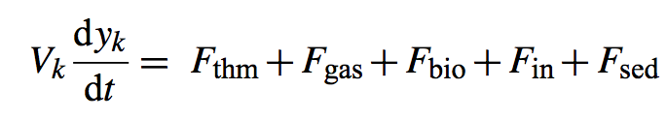
where y_{k} is an ocean tracer, V_{k} is the volume of box k, and F are fluxes due to thermohaline circulation, air-sea gas exchange, biological uptake and remiberalization, riverine/weathering input, and sediment flux, respectively.

Both models include the carbonate chemistry of the ocean, which was discussed in class. This is in ‘csys.c’ in the Loscar directory.

Refresher on carbonate chemistry (from Zeebe, Annual Reviews, 2012):
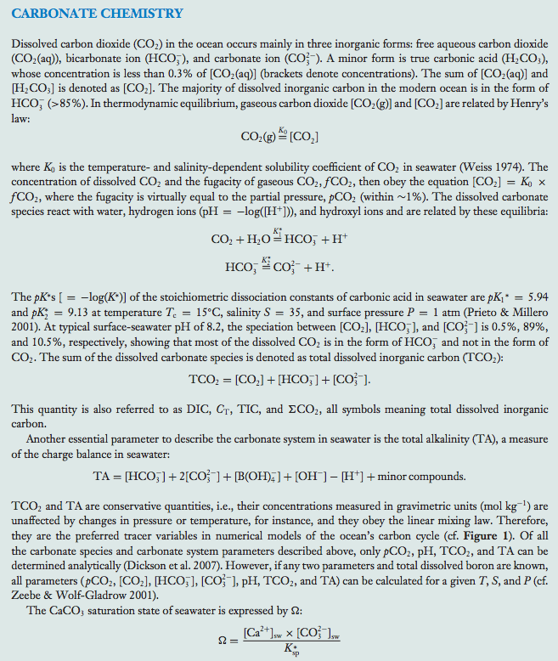

Purpose of class. The purpose of the class is to walk through the models for two recent papers – Zeebe et al. Nature Geoscience 2009 applying Loscar to the Paleocene-Eocene Thermal Maximum, and Tziperman et al. Proc. Natl. Acad. Sci. 2011 applying Tziperman’s biogeochemical model to the initiation of the Neoproterozoic Snowball Earth events - to explore the assumptions that were made, and the sensitivity of the claims in the papers to those assumptions.

The PDFs of these papers are on the class website (scroll to ‘Week 9’).

Instructions.
1. Go to the class website http://geosci.uchicago.edu/~kite/geos32060/,
Scroll to “Week 9” and download the loscar_option_2.zip and
tziperman.zip files. Unzip both files to separate directories.
2. If there are problems running loscar.zip, let me know.

Understanding the default Loscar scenario.

3. Type ./loscar.x prepetm.inp >& loscar.log
(pre-PETM initialization parameters, dump output to a log file). This is a Paleocene-Eocene Thermal Maximum scenario.
4. Inspect the loscar.log file with your favorite text editor. To access the text editor you may need to run ‘Applications Utilities Terminal’. Notice the key input parameters: CINP, the amount of C added, D13CIN, the isotopic “fingerprint” of the added C (in this case, -55 per mil is reasonable for microbially-produced methane), and TCIN0, the duration of the perturbation. Notice also that PCO2SI (the initial atmospheric PCO2) is 2.5x the present level (4x preindustrial).
5. Load Matlab, cd to the loscar directory, and run PlotLoscar.m. Many figures should be generated. Inspect Figure 7 from the MATLAB output: the input ‘spike’ in CO2 is the forcing for this scenario.

In Figure 1 of the Matlab output, The codes LA,LI,LP,IA,II,IP,DA,DI,DP,H, (LT,IT,DT) can be read as follows; L=Low, I=Intermediate, D=Deep, A=Atlantic, I=Indian, P=Pacific, H=High latitude box, (T=Tethys).

In Figure 1, the vertical gradients within each ocean box are due to the biological pump (export of isotopically-light carbon by (i) the sinking aggregates of dead plankton bodies and (ii) animal feces).

Notice the differences between Fig. 1 (Dissolved Inorganic Carbon) and Fig. 2 (Total Alkalinity). Total Alkalinity is approximately equal to [HCO3-] + 2x[CO3(2-)]; DIC is [CO3(2-)] + [HCO3-] + [CO2*] + [H2CO3].

You can ignore Figures 3-5.

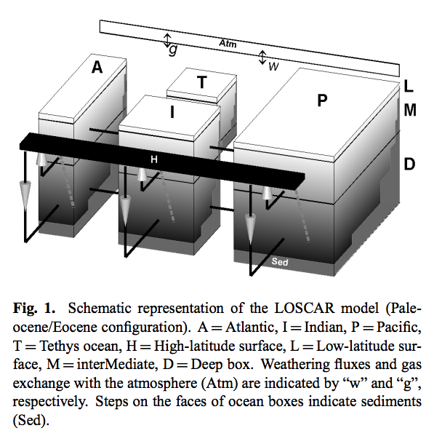
From Zeebe, Geochemical Model Development, 2012.

Figure 6 shows that the carbon-isotope excursion is superimposed on a fixed offset between the different ocean basins. The Pacific is isotopicaly lighter than the Atlantic. This is because the ocean basins are in different positions along the ocean thermohaline circuit (deep Pacific waters are older, than deep Atlantic waters). The timescale for the ocean circulation is ~10^3 years. Older waters are more acidic, nutrient-rich (especially phosphate), oxygen-poor, and DIC-rich. Upwelling re-equilibrates the ocean with the atmosphere (by bringing water to shallow depths where wave stirring is effective), and ‘resets’ ocean composition. The Tethys ocean, which was destroyed by the collision of India and Africa with Eurasia, is modeled as a restricted sea (old waters).

Figure 9 shows ocean acidification. In this scenario, the oceans become more acidic by ~0.05 pH units. Figure 17 summarizes, and Figures 13-16 show in detail, the effect on seafloor CaCO₃ sediments. Pressure stabilizes calcite so that in both the modern and PETM ocean, calcite is stable below a critical Calcite Compensation Depth or CCD (Fig. 17). The CCD is deep in ocean basins that contain young water and shallow in ocean basins that have older water / restricted circulation. At intermediate depths, calcite sediments dissolve in the more-acid oceans, for several hundred Kyr before CO₂ is neutralized by terrestrial weathering.

Take screenshots or snapshots of important figures (Command + Shift + 4 on a Mac). Don’t worry if you lose a couple of figures because Loscar run time is only a few seconds. Save the output for this default run and check that you can load the data back:

save defaultoutput %or any filename you wish
clear
a = load('defaultoutput')

5. Clear variables, go back to command line,

cp prepetm.inp prepetm.morecarbon.inp

Edit prepetm.morecarbon.inp by increasing CINP to 5000.

Rerun from the command line

./loscar.x prepetm.morecarbon.inp

Rerun (in Matlab) PlotLoscar (clear all variables and ‘close all’ first)

Try to understand the differences between this and the earlier (default) low-C-injection scenario.

When you reach Figure 17, notice the ‘scalloped’ appearance of the CCD curves. Is this real?

Here is a synthesis on observational constraints on CCD depth before (left column) and during (center column) the main PETM event:

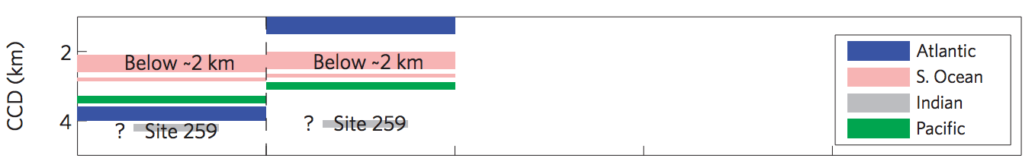
Referring to your output for the 1000 Pg C and 5000 Pg C release scenarios, what constraints do the data place on carbon release?

6. Using the editing pattern established above, try altering the FBIOL parameter (biological pump strength) within the ‘useful range’ stated in the commented-out header of each *.inp file. Inspect and try to understand the results.

Looking under the hood of Loscar.
7. There is no way to change the strength of the individual parts of the thermohaline circulation (i.e. the strength of mixing between each box in the model ocean) without editing the source code. Copy the source code into a backup directory. Then open initfree.c and search for “thc0”. Inspect the surrounding code.

Search for ‘tsnsflag’, but do not change it. Grep or otherwise locate the other location in the source code (not in this file) where tsnsnflag is used. Is temperature handled in the same way as carbon? If not, why do you think not?

8. Grep or otherwise search for “issue”, “kludge,” “unexpected,” and any other “red-flag” word you can think of in the source code.

9. In your modified PETM input file, switch the TSNS flag to 1 and inspect the results. Next, reduce the duration over which the carbon is injected to 100 years and inspect the results. Compare the response of the different ocean basins.

Understanding the default Tziperman scenario.
Download and unzip the Tziperman model from the class website. The Tziperman model is a refinement of an improvement of the Rothman model which we discussed in class and which is on the required reading list.
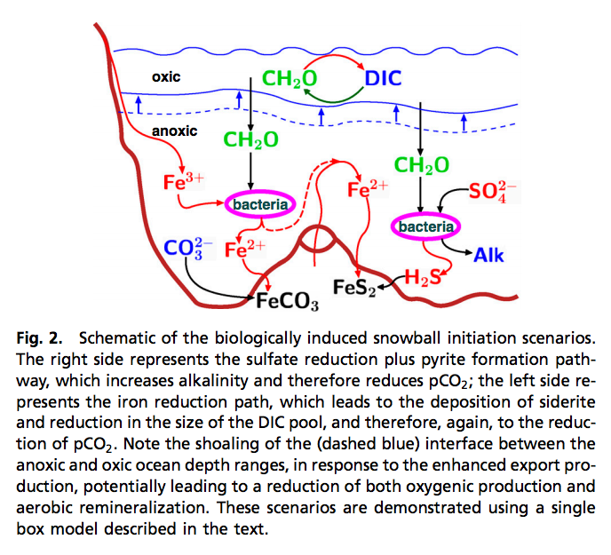
One problem with the Rothman model is that the oxidation of organic matter required to explain the isotopic excursions (per Rothman) would release CO2, inhibiting snowball initiation – but the snowballs appear to have started right after the isotopic excursions. In the Tziperman model, the most recent Snowball Earth episodes are triggered by an increase in the export of organic matter from the shallow to the deep ocean. Because the deep ocean contains very little oxygen before the Cambrian Explosion, the organic matter is respired by sulfate reducing bacteria and by iron reducing bacteria. The (indirect) result is burial of C as FeCO₃ and release of alkalinity, both of which lower pCO₂. The resulting decrease in CO₂ triggers the Snowball, right after the isotopic excursions, as required by the geologic data. (The pdf of the Tziperman paper is on the class website).

Enter ‘eukaryotes(1)’ at the command line and run. This may take a few seconds.
The results are stored in ‘Output/Figures_pdf’.

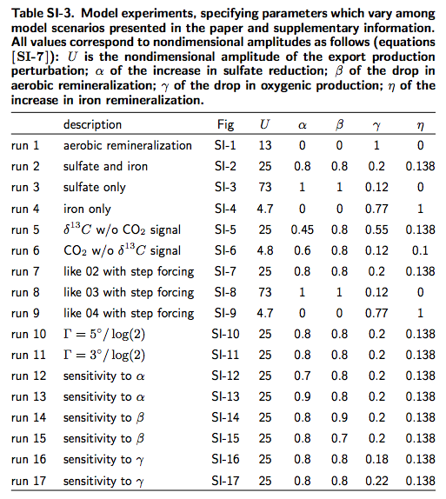
eukaryotes(1) corresponds to run 1 above. Could this input trigger a snowball? Why? Could organisms with calcite shells evolve around this time? Why?

Run eukaryotes(2), corresponding to run 2 above. Could this simulation explain Neoproterozoic data? What is the total amount of oxygen produced in this scenario (in units of % of today’s atmospheric level of oxygen)?

Locsar may be compiled by opening a command line interface, changing directory to the loscar directory, and typing ‘make loscar PALEO=1’
vi.

